**Assignment 5:**

You have one Jenkins Master server and 2 slaves connected (JNLP or SSH), you to create .war file on Jenkins master and then deploy war on both slaves. Both slaves have Apache tomcat preinstalled.

**Step 1:** Prepared Jenkins master server and installed maven on it using zip file..

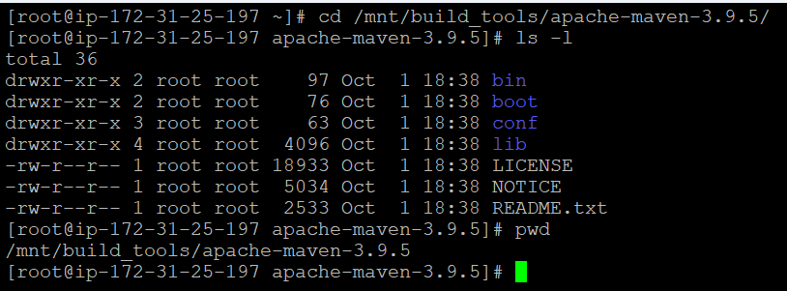

Also setup environment variable for maven so that maven can be launched form any promt location

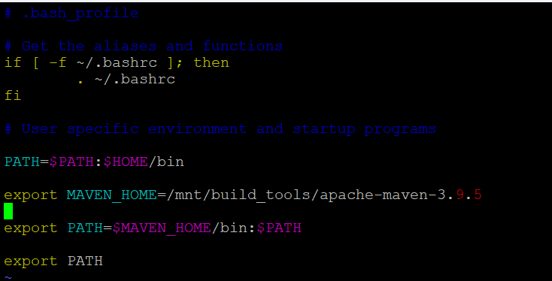

**Step 2:** installed git

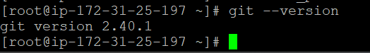

**Step 3:**

We have already installed and launched Apache tomcat on both the slaves,

Also created and saved .pem keyfile for slaves on Jenkins Master.

Configured both the slaves with private IP for SCP on master server using CLI.

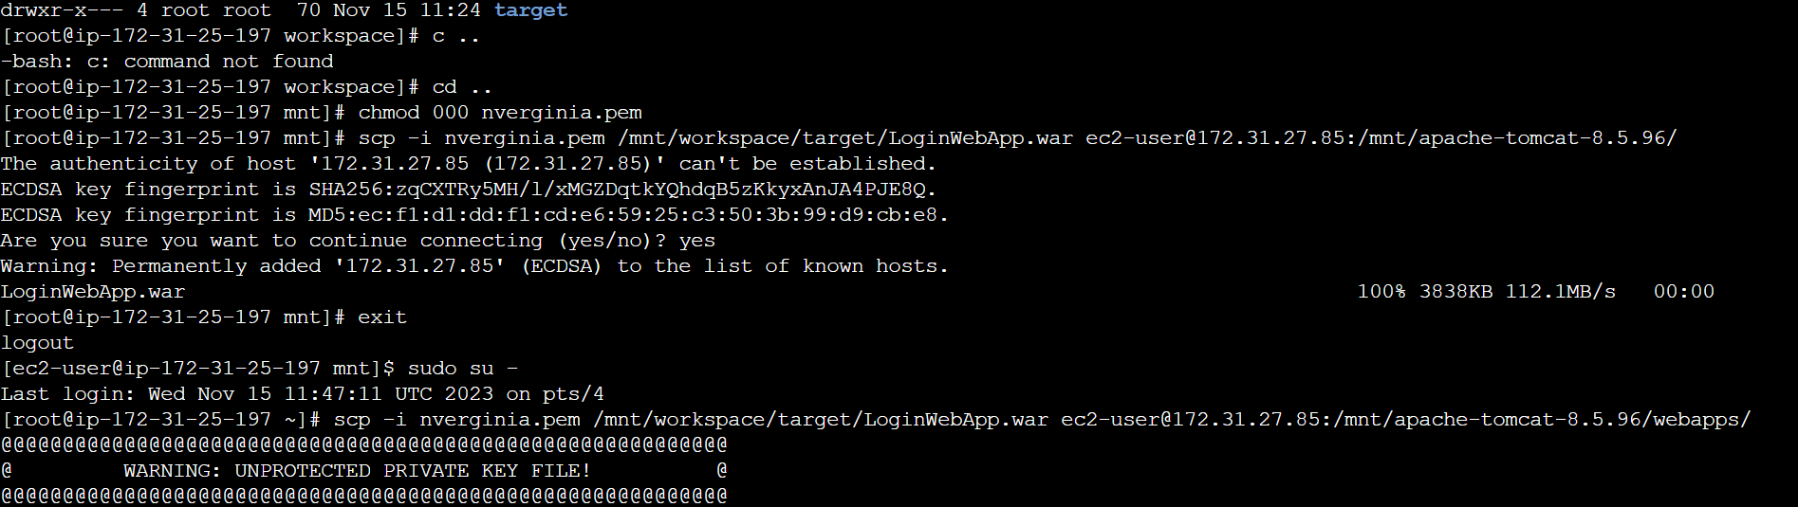

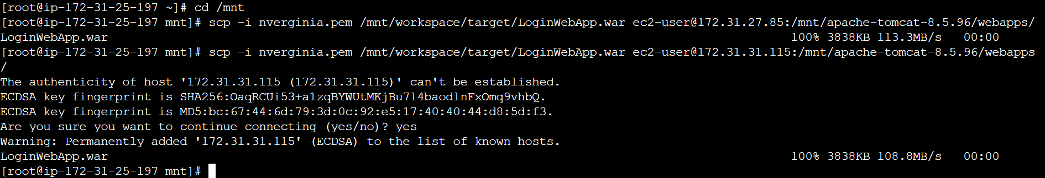

**Step 4:** Created a pipeline job with below script:

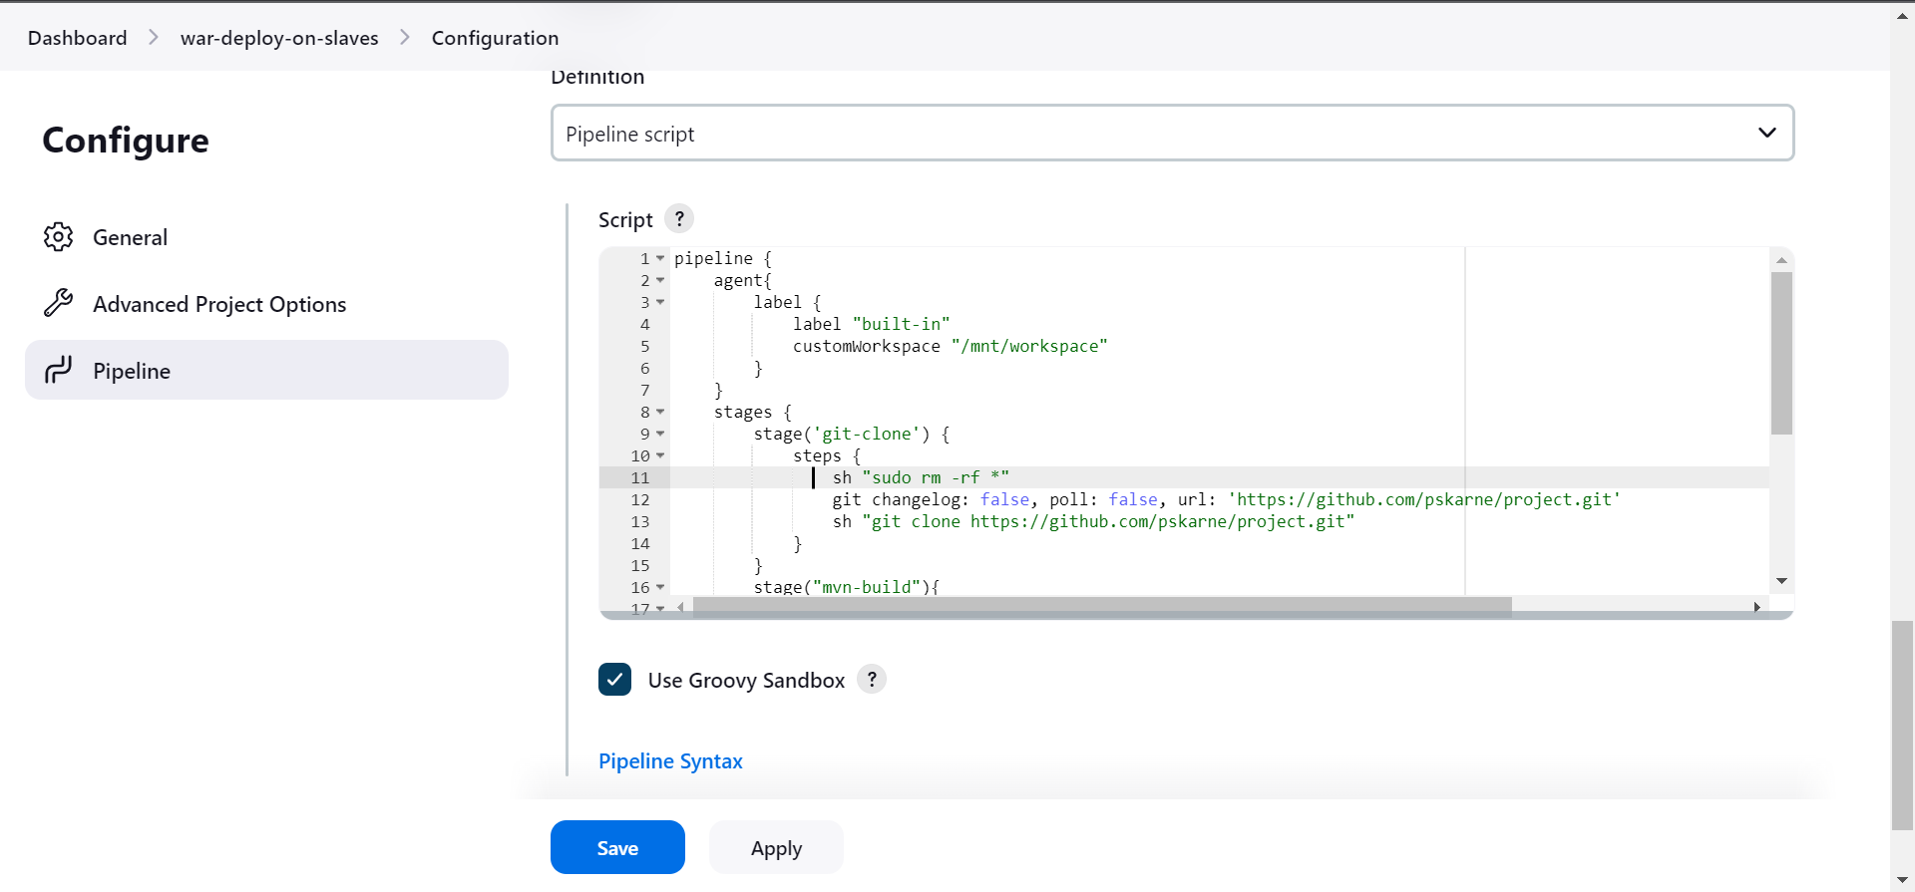

|  |
| --- |
| pipeline {  agent{  label {  label "built-in"  customWorkspace "/mnt/workspace"  }  }  stages {  stage('git-clone') {  steps {  sh "sudo rm -rf *"  git changelog: false, poll: false, url: 'https://github.com/pskarne/project.git'  sh "git clone https://github.com/pskarne/project.git"  }  }  stage("mvn-build"){  steps{  sh "cd /mnt/workspace/project"  sh "mvn clean install"  }  }  stage("war-deploy"){  steps{  sh "scp -i /mnt/nverginia.pem /mnt/workspace/target/LoginWebApp.war ec2-user@172.31.31.115:/mnt/apache-tomcat-8.5.96/webapps/"  sh "scp -i /mnt/nverginia.pem /mnt/workspace/target/LoginWebApp.war ec2-user@172.31.27.85:/mnt/apache-tomcat-8.5.96/webapps/"  }  }  }  } |

**Successfully Build the Job**

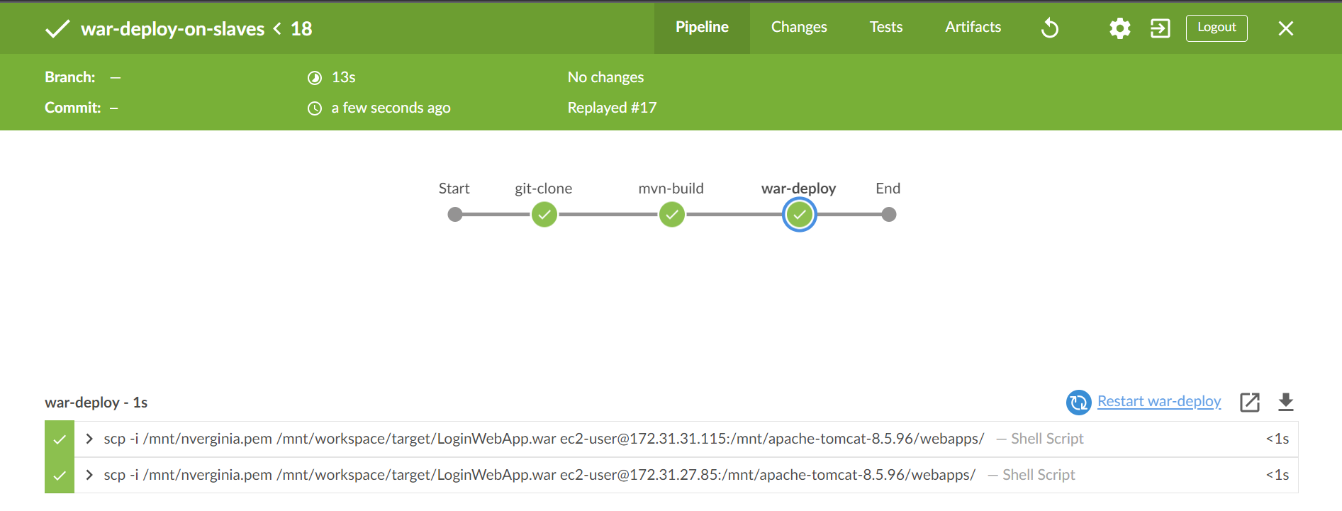

**Output from Slave-1**

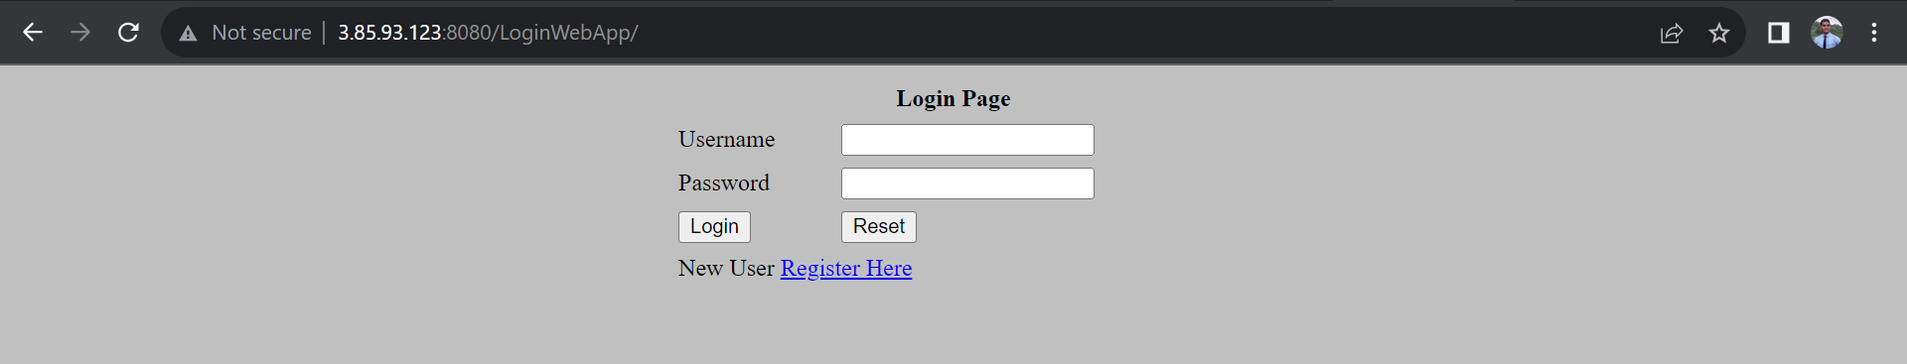

**Output form Slave-2**

